Dan Williams

Final Project Objective 7. - Layouts and Screens Explanation

Analysis of Software Systems

11/30/20

Within the creation process for designing unique screens and layouts associated with the HIPA application, there were three different types of layouts and screens that were determined to need to be designed: screens for the mobile-only version, sketches for the appearance of the different holograms that are apart of the holographic interface, including the sketch of what the interface will appear like while in use, and the design used for the watchOS watchface for the application. This specific document contains multiple screens from the mobile-only version of the application, as well as examples of different types of pop-ups and information that will be present on other screens/sections of the mobile-only version as well. There are also other sketches located in this folder that detail all of the different designs for the holograms and how they are being anticipated to appear to users, as well as a prototype sketch of the design for how the holographic interface will appear to users while there are multiple holograms being displayed together at once. These sketches have been drawn with a certain “toughness” and lack of polish with them, and this is intentional, as the ruggedness of the sketches is meant to highlight how the digital-appearance of the holograms will not always be as perfectly smooth as a project image on a monitor, or how smooth a physical object can be, such as a computer or iPhone itself. There is also one sketch that details the appearance of the watchOS watchface for this application as well. All of the design choices including colors, size of text and buttons, incorporated functionality, and locations of buttons and text fields were all meticulously considered and designed with the proper user interface in mind. However, this is all subject to change as proper analysis from different design analysts and teams continue to evolve and learn as the process of development continues to evolve and progress.

The follow screen is the home screen for the mobile version, and will be necessary to navigate through in order to activate the holographic interface:

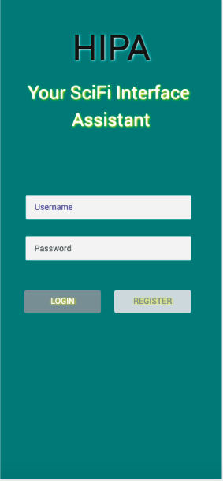

After users navigate past this screen and either log into their account, or create a new account through Seventeen Solutions, the following screen displays, and will be the last screen that those who choose to use the holographic interface will see:

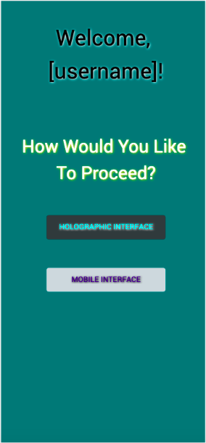

Upon selecting the holographic interface, users will be prompted to place their phones screen up, apply the HIPA Grip to their index finger and thumb, and interact with the holographic interface from there. Should a user choose to use the mobile interface, this is the following screen that results:

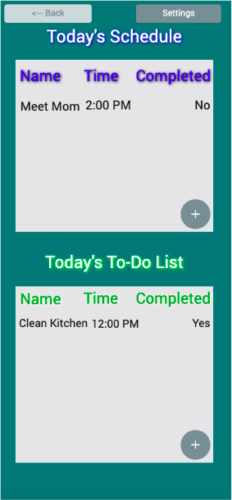

While this screen may be basic, it is meant to continue to apply the simplistic design approach that has been preached across all stages of this project, since the primary objective of this project is to establish a holographic interface as a reliable medium to consume and operate technology. Upon pressing the ‘+’ button at the bottom-right hand corner of each section of this screen, there will be a modal pop-up displayed prompting the user to give a name for the new task/event. Once the task or event is created, the user can tap the empty time slot that will be next to the name to apply a time. After a time is entered, the user will be prompted if they would like to enter a date for the event or task as well. For both the date, as well as the time inputs, the application will utilize a scrollbar in order set these parameters accurately, such as with the pop-up shown below.

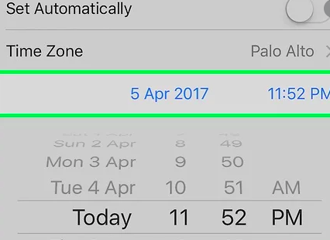

The settings button will also take the user to an exhaustive list of the varying different settings that users can toggle between the mobile only version and within the holographic interface as well.